**PROCEDURE IN SETTING UP THE ESP8266 DEVICE**

* Connect the device as specified in the circuit diagram.

1. DHT11 sensor has three pins called GND,VCC and SIGNAL (DATA)
2. Connect the VCC pin to 3.3V supply, GND to GND and SIGNAL pin to D1 of NodeMCU (GPIO5)
3. RED and BLACK wires of the sensor are connected to +3.3V and GND, respectively (refer attached photo). The YELLOW wire (data) is connected to the pin 1 (D1, GPIO5) and pulled up to +3.3V with 1k - 10k resistor.

**NodeMCU board:**

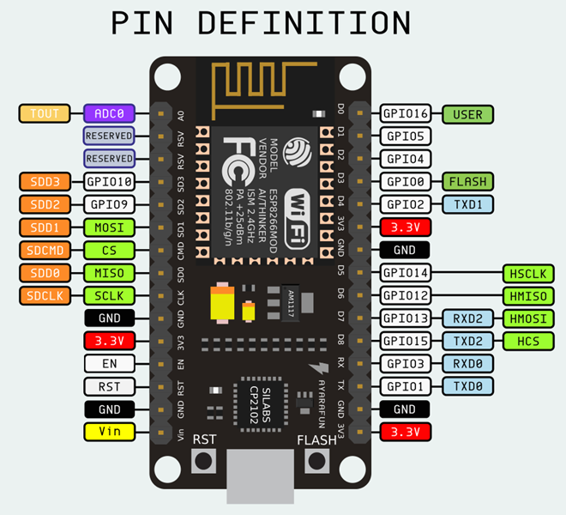

**NB:** YELLOW color wire -> SIGNAL or DATA pin

RED color wire -> VCC (3.3V)

BLACK color wire -> GND (Ground or reference)

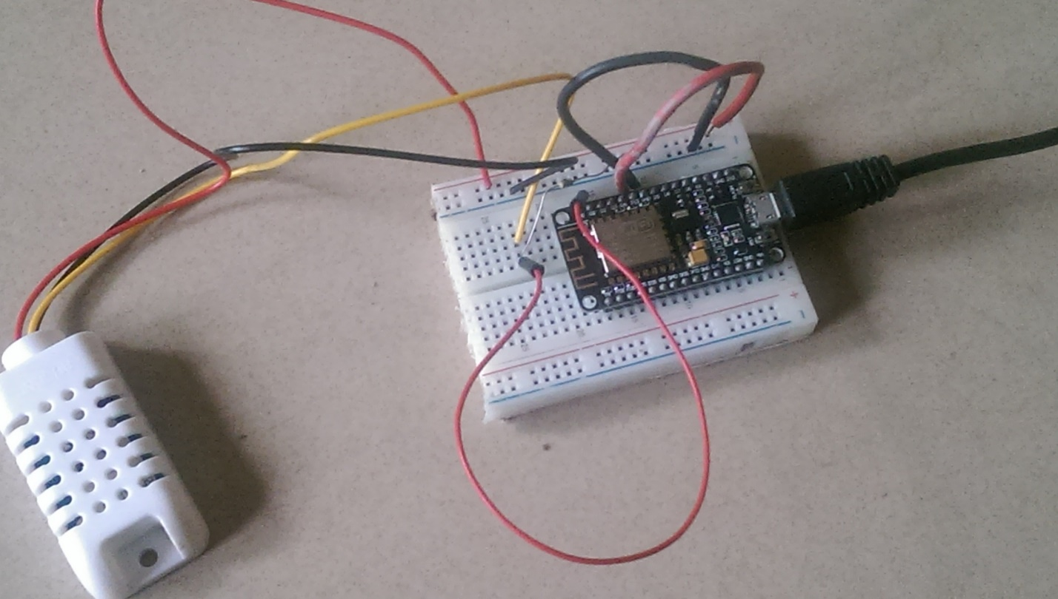

* Ensure your computer has Java and Python installed on it. You can check if your system has python and java install by running this code in your window terminal.

java -version

python –version

As at the time of preparing this doc. We made use of the latest version of Python and Java.

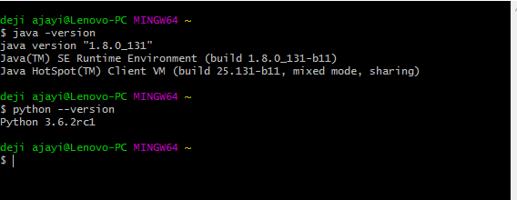

You can also install python on your terminal using this link.

<https://www.python.org/ftp/python/3.6.2/python-3.6.2rc1-webinstall.exe>

* Download the esptool which will be used for flashing the device from [here.](https://github.com/espressif/esptool)

Esptool is a python based utility use to communicate with ROM bootloader in ESP8266 and ESP32 chips. Esptool can be install via pip on your terminal. Pip is a python package manager.

If you already have python running on your system, you can install esptool from your terminal using pip install esptool

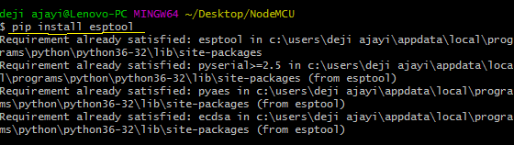

**NB: you should get a different message on your terminal screen if it’s your first time installing esptool. This screenshot shows the esptool has already been installed.**

* Connect the device to your system using the USB cable.
* Open the device manager to check the port number of the connected device.

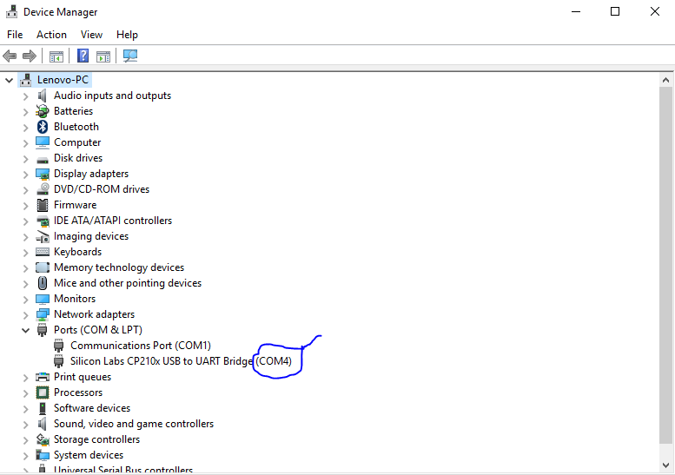

* Please install Git on your system. You can proceed if you already have Git installed. You can download git from the link below. Please ensure you select your PC type. <https://git-scm.com/downloads>
* Create a folder on your desktop and cd into it.

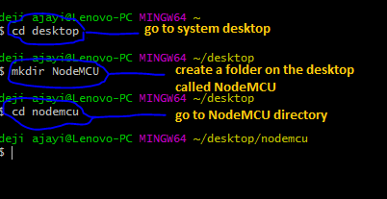

* Clone the project github repository from your terminal using this snippet.

**git clone** <https://github.com/gabod2000/NodeMCU-client>

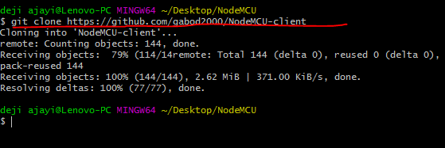

* CD into the project file and flash the device.

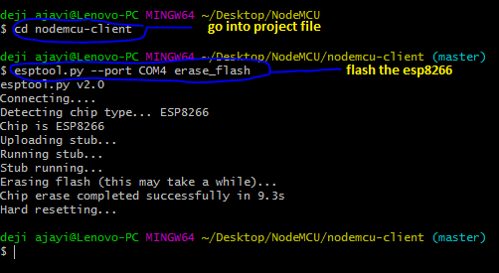

* CD into firmware folder and program the LUA code into the esp8266 device. Here is a sample code and a screenshot.

***esptool.py --port COM4 write_flash 0x00000 nodemcu-master-13-modules-2017-02-11-20-55-17-float.bin***

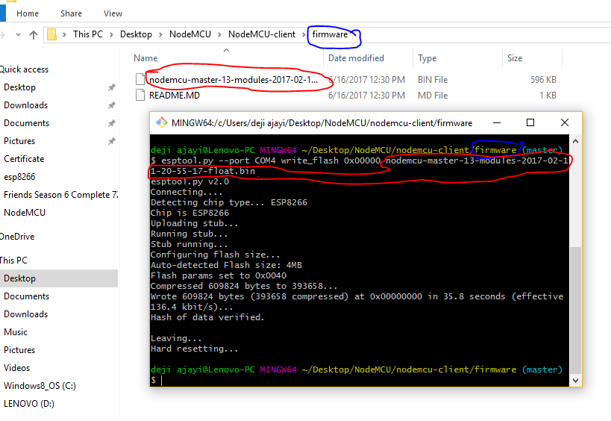

* Check the MAC address of the esp8266 device and note it down.

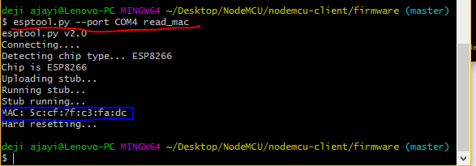

* Generate key for the esp8266 device by editing and running the python script to generate key. Edit the MAC address, Email and Password in the python script. Here is the code snippet. Please note that you must be a Terasys administrator to be able to generate key.

#Login

import requests

url = "https://www.terasyshub.io/api/v1/login"

payload = "{\n\t\"email\":\"user@gmail.com\",\n\t\"pass\":\"password\"\n}"

headers = {'content-type': 'application/json'}

response = requests.request("POST", url, data=payload, headers=headers)

print("\n")

print("Login Token:")

print(response.text)

print("\n")

text_bkp = response.text

#Regenerated the KEY

url = "https://www.terasyshub.io/api/v1/keys/5c:cf:7f:c3:fa:dc/regen"

payload = ""

headers = {'authorization':'JWT {}'.format(response.text)}

response = requests.request("POST", url, data=payload, headers=headers)

print("Regenerated KEY:")

print(response.text)

print("\n")

#Get the KEY

url = "https://www.terasyshub.io/api/v1/keys/5c:cf:7f:c3:fa:dc"

payload = ""

headers = {'authorization':'JWT {}'.format(text_bkp)}

response = requests.request("POST", url, data=payload, headers=headers)

print("KEY:")

print(response.text)

print("\n")

**if you don’t have an administrative account, you can create one by editing and running this Python script.**

import requests

url = "https://www.terasyshub.io/api/v1/registerAdmin"

payload = "{ \r\n \"password\":\"password\",\r\n \"password_confirm\":\"password\",\r\n \"email\":\"user@gmail.com\",\r\n \"profile\": {\r\n \t\"firstname\":\"Test\",\r\n \t\"lastname\":\"Test1\"\r\n },\r\n \"key\":\"8JadZIptT2ysZPKQUAdBWw.lwewT8M4\"\r\n}"

headers = {'content-type': 'application/json'}

response = requests.request("POST", url, data=payload, headers=headers)

print(response.text)

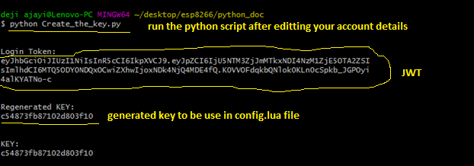

* Use google map to get coordinate of the site location and edit the config.lua file accordingly. Open google map on your phone or PC browser and type in the address where the device will be installed to get the address latitude and longitude.

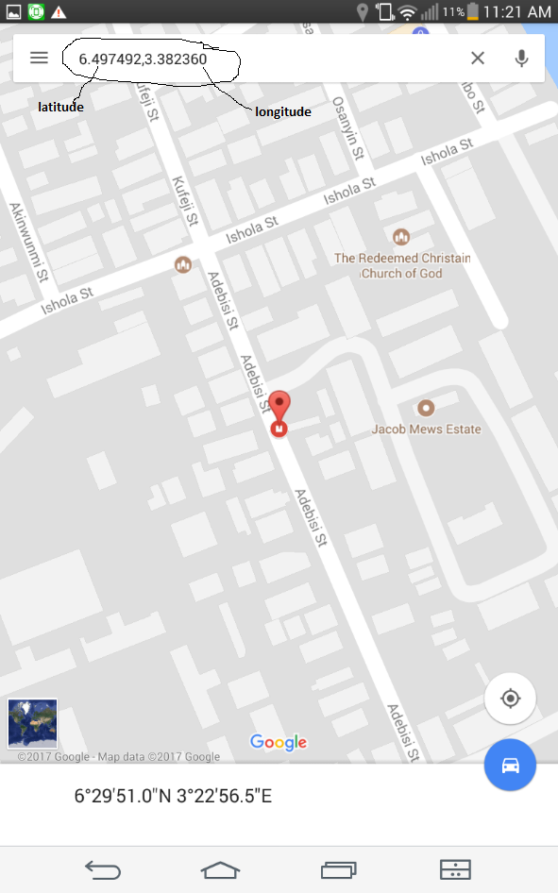

* Edit the config.lua file.

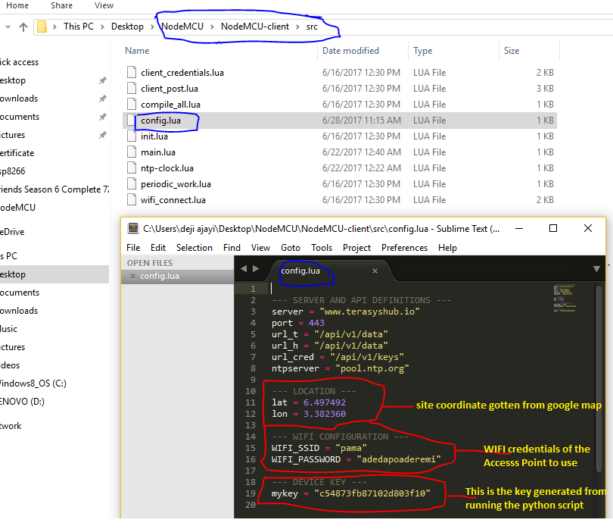

* Download and run the Esplorer from this [link.](https://esp8266.ru/esplorer/) Run the .jar file and select the appropriate speed and port.

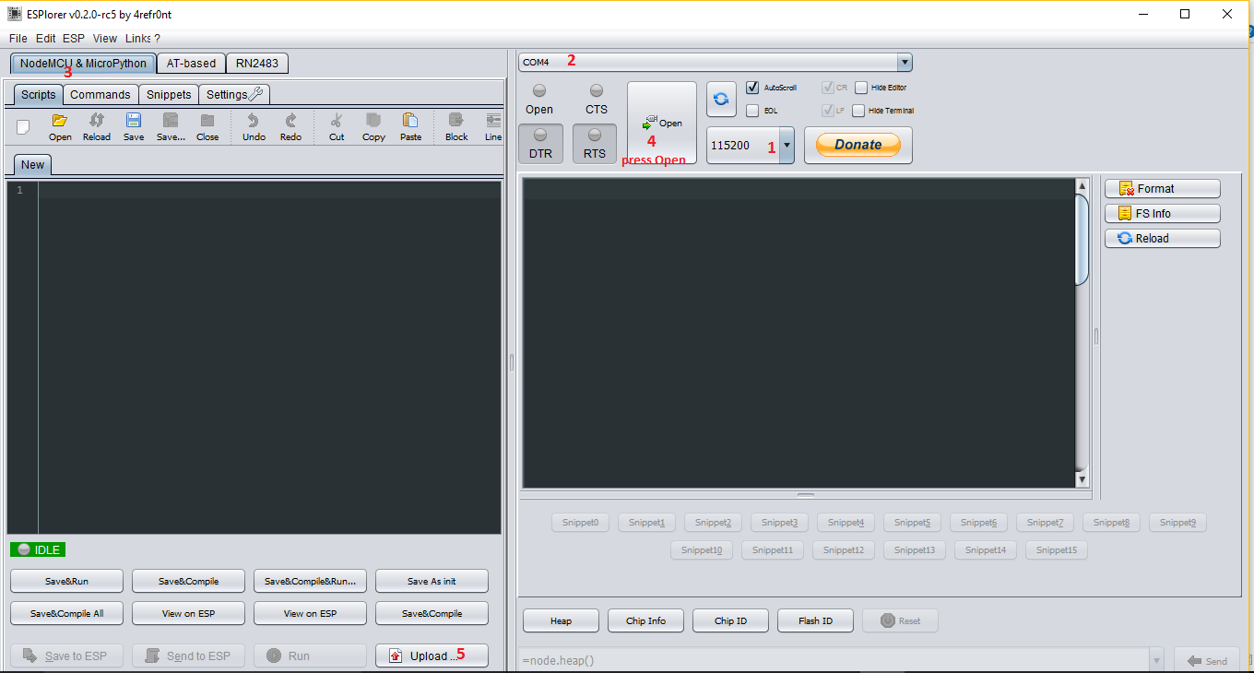

* Select and Upload all the LUA code in the src folder into device.

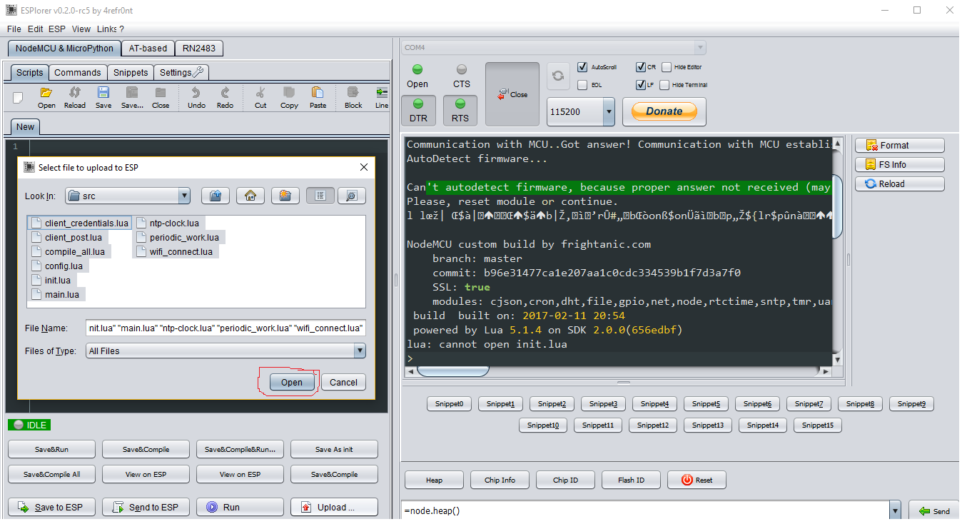

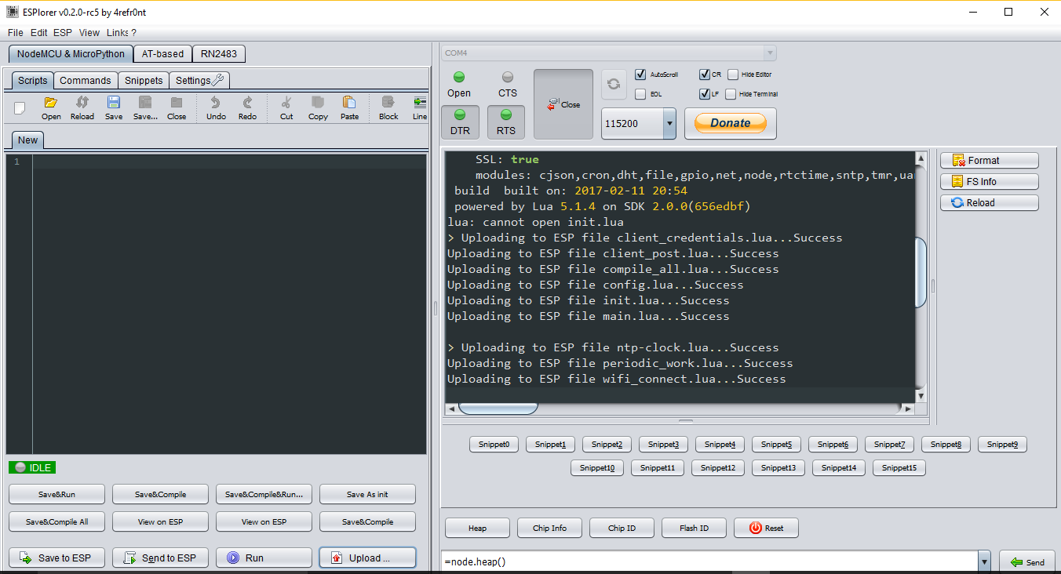

* Compile the compile_all.lua file. Follow the 3 steps in the screenshot below.

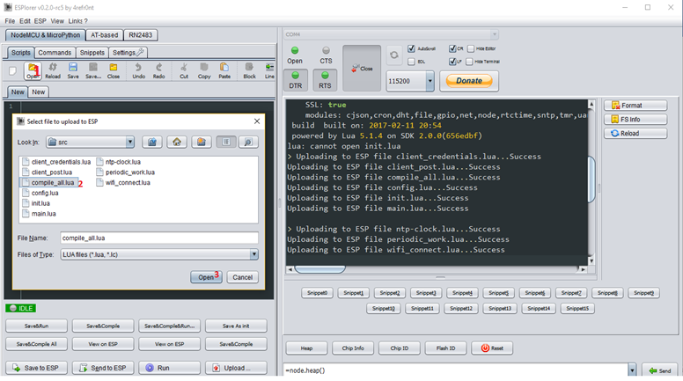

* Click **Run**

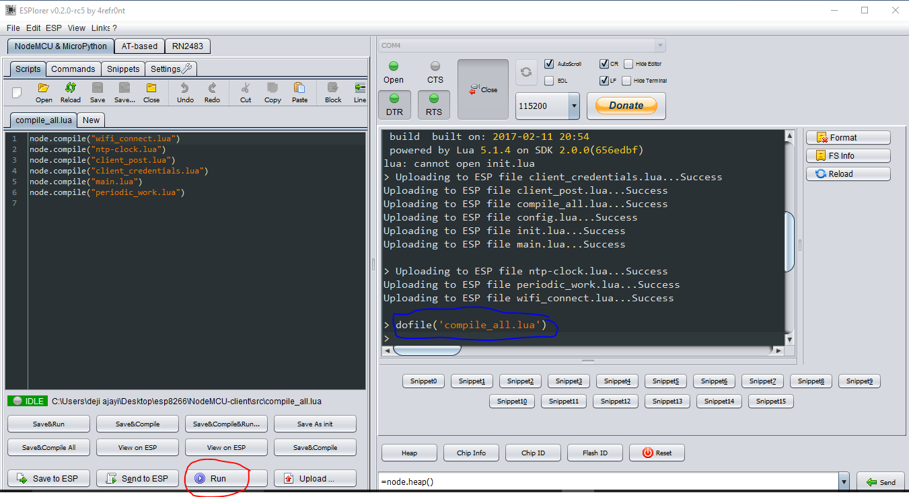

* Restart the device by clicking **Close** and **Open** it again for the device to reboot. You can also reboot the device by clicking **RTS** button.

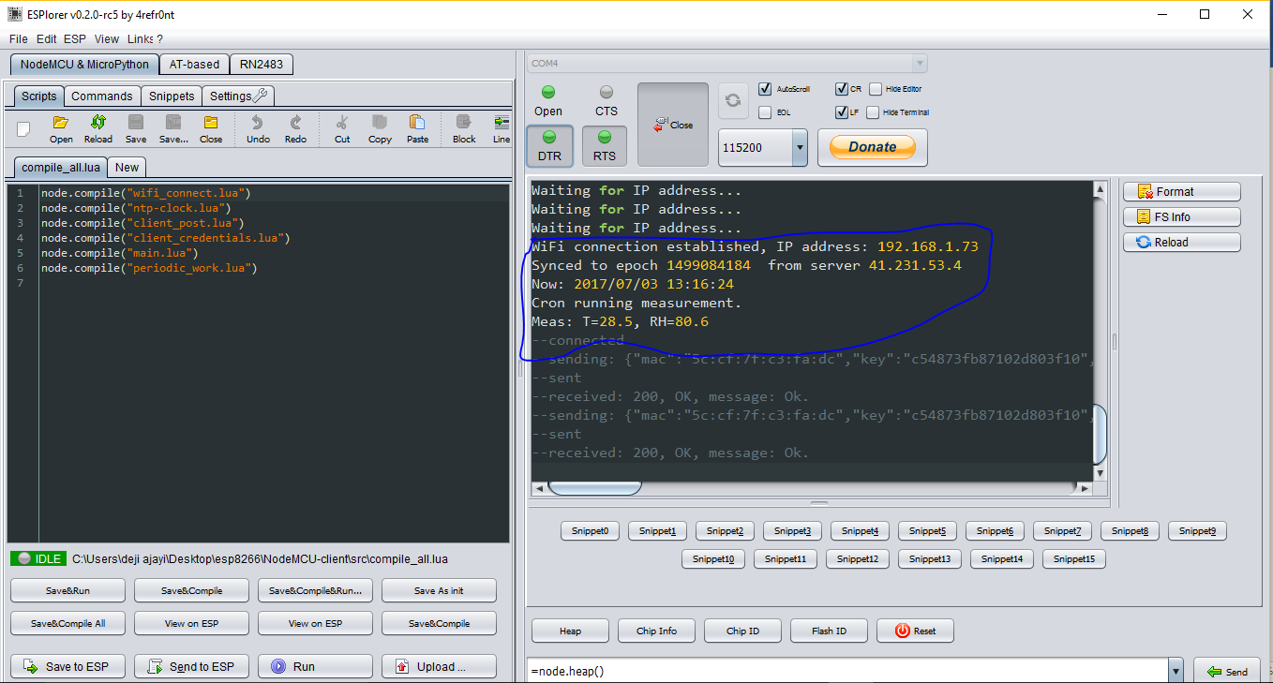

* You have successfully configured the device, but you need to add the device to a group on the Terasys IoT platform. To do that, follow the instruction in the Terasys API documentation.
* Download Postman from this link <https://chrome.google.com/webstore/detail/postman/fhbjgbiflinjbdggehcddcbncdddomop?hl=en>

**Please note** that Postman is an extension on Google Chrome. Ensure you have Google Chrome on your system before you install Postman.

* Open Postman and create a group or add the device to a group.

**NB:** you will need to login to generate JWT to be use for Authentication.

* Login to generate JWT. Note down the JWT because you will need it in subsequent HTTP request. Also note that the JWT expires in about 10 mins.

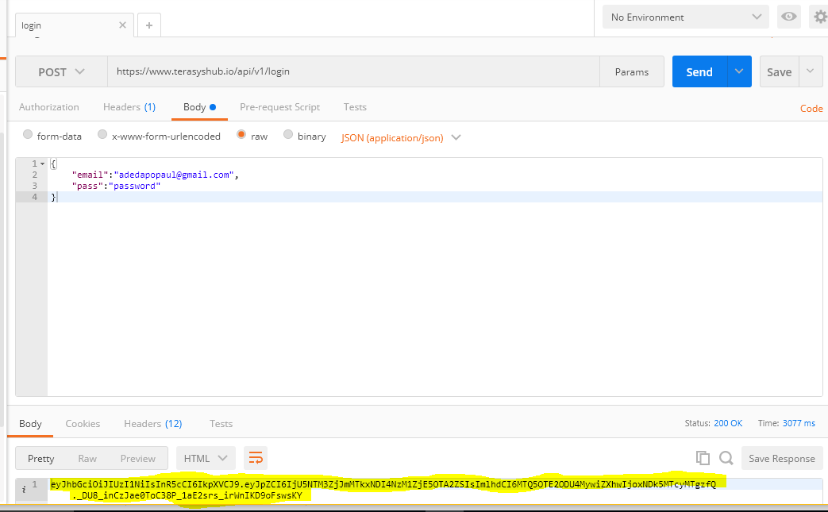

* Update or create group as the case may be. Add the device Mac address to the group. Check Terasys API documentation for the appropriate API in this link <https://documenter.getpostman.com/view/2250700/terasys-api/6fU36eT#082ab1a2-b28e-98c0-9ff5-1a51f8da23f6>

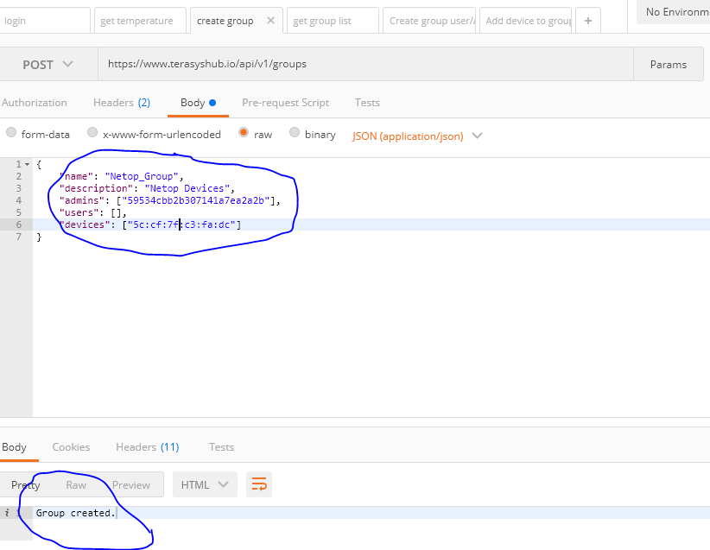

* Get the group ID by making a GET request

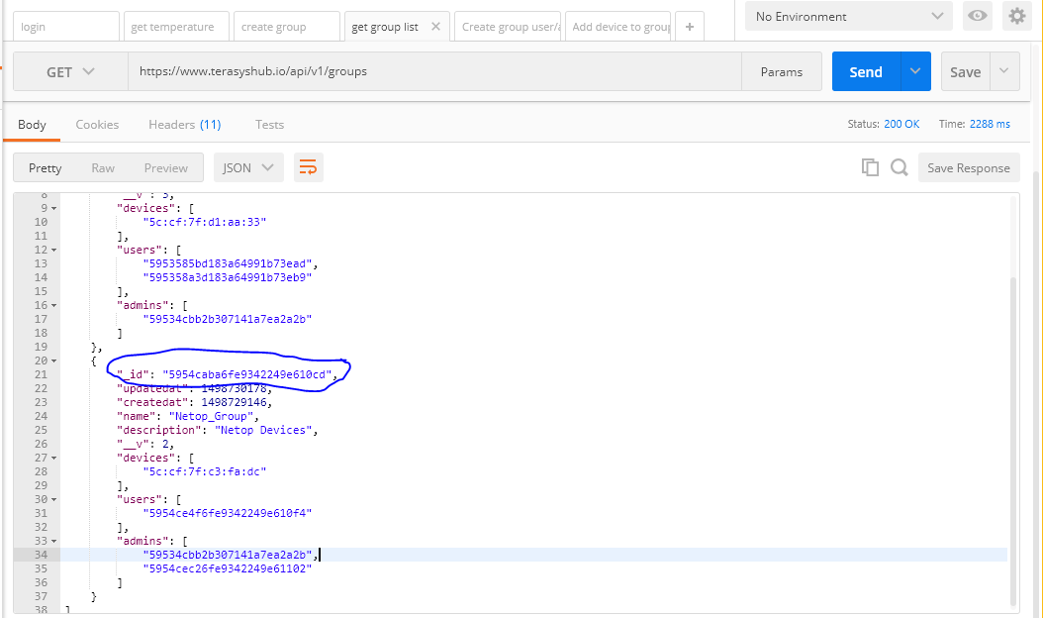

* Add the device to cloud

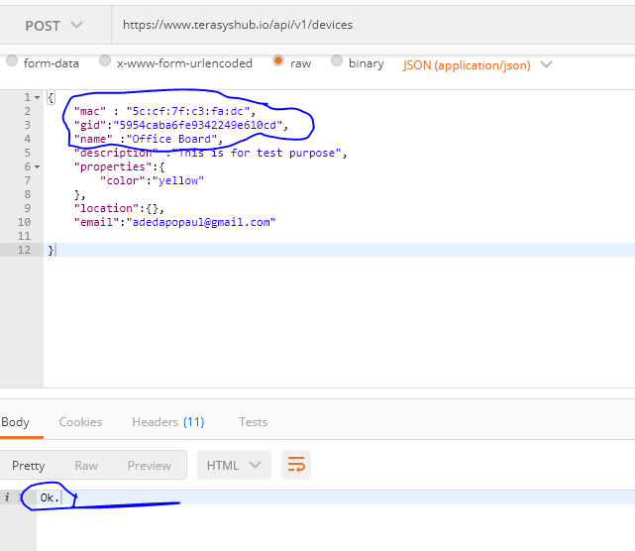

* Log in into Terasys GUI platform to view the device.

